Friends and Family Comments November 2022
RESULTS: 47

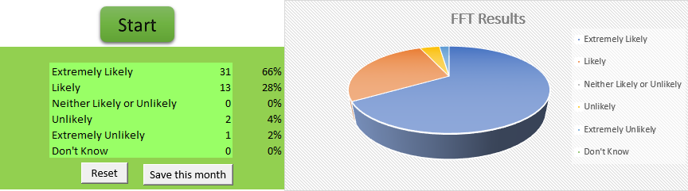

- Good communication everything explained clearly
- Blood test in & out in seconds
- Since I've been with the GP practice everyone I've seen been very helpful about my health and revered me to the right people
- Mo was friendly and professional. I felt at ease
- Appointment on time. Pleasant staff
- Everybody is so helpful and kind, very easy to get appointments, really feels like everyone cares
- Anita Scott is a very good experienced nurse with excellent knowledge and advice given
- Happy to have Anita back, lovely and friendly as always
- Very friendly and no problems in waiting time
- Very prompt no waiting around doctors were very efficient and professional
- Mo was very thorough and professional
- Good and informative
- Satisfied
- No problem
- Like the nurse who I see
- Everyone is very professional and friendly and they keep you well
- Reassuring and listens
- Efficient
- Very efficient and knowledgeable
- Check-up very good
- It answered some of my questions
- Very good
- Got seen on the same day .and given medication
- Excellent meeting with full explanation of next steps
- I was pleased with the Doctor I saw
- It all went very well, with no problems
- I'm happy

